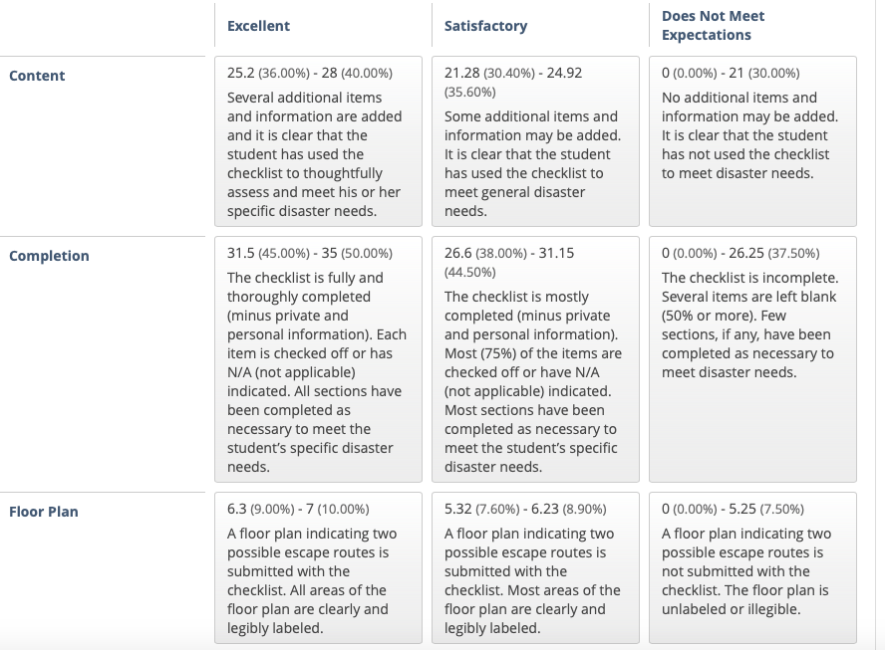

Complete the Assignment Checklist. Check off items that you have in inventory.

- For items that are not applicable to you and your living situation, please write N/A (not applicable) in the space, otherwise it will be counted as incomplete.﻿
- Remember to protect personal information by using pseudonyms, or by providing only partial information
  - ​Ex: Sister: Britley *****, phone: 724-***-****, email: b********@yahoo.com
Review the rubric for more information on how the assignment will be graded.
Please note: You are not required to purchase any items on this list, however, take note of the items you are missing and consider how it could impact your safety and survival in a disaster.

My Family’s Disaster Plan
Learn about the natural disasters that could occur in your community and how you can respond to them. Provide at least two references and sources of information. Use APA Style for your reference.
Possible hazards in my area:
1.____________________ APA source reference: __________________________
2. ____________________ APA source reference: __________________________
3. ________________________________________________
4. ________________________________________________
5. ________________________________________________
6. ________________________________________________

Emergency Phone Numbers
(Program these into all phones and post in a common area in the home.)
- Police department:
- Fire department:
- Local emergency services:
- Healthcare provider(s):
- Local American Red Cross:
- Poison Help: 1-800-222-1212
- Other local emergency personnel numbers: ___________________
- ___________________
- ___________________

Employers and School Officials Contacts
I know the emergency response plans for employers and schools. _____
School:
Address:
Phone:
Contact name:
Child | Day Care/School | Phone #

Employer:
Address:
Phone:
Contact name:
Employer:
Address:
Phone:
Contact name:
Family Communication Plan
Prepare a family communication plan so that each member of the family can contact one another quickly.
- Everyone has a cell phone or calling card _____
- Young children know how to call (numbers are saved) ______
Name | Contact Name | Phone | Email

Identify two meeting places for your family in the event that you are separated.
Near your home:
Location:
Address:
Phone:

Away from your home (in the event you cannot return home):
Location:
Address:
Phone:

Draw a floor plan of your home and attach it to your submission; mark two escape routes from each room. ______

Pick a friend or relative who lives out of the area for household members to call/email to say they are okay.
Name:
Phone:
Email:

Everyone in the house knows how and when to shut off utilities. ______
Utility Name | Number | Shut-Off Location/Main Controls
Electric
Water
Gas

Evacuation Plan and Transportation
Extra gallon of gas ______
Local government resource ______
Contact person/agency:
Address:
Phone:

Certifications
Stay current and up to date (e.g., CPR, ACLS, PALS, TNCC).
- Certification #1:
- Date of Completion/renewal:
- Certification #2:
- Date of Completion/renewal:
- Certification #3:
- Date of Completion/renewal:

Property, Health, and Financial Well-being
Review property insurance policies for disaster policies. ______
Current ______
Appropriate to needs ______
Review life-insurance policies. ______
Current ______
Appropriate to needs ______
Review health insurance policies. ______
Current ______
Appropriate to needs ______
Review financial documents. ______
Emergency savings $______
Easily accessible, small cash savings $ ______
Important Documents and Items Secured
Make sure you have copies of important documents and items that can be stored in a fireproof watertight container.
Important Items | Check off Photocopied Items That are Safely Stored
Personal identification
Cash and coins
Credit card(s)
Extra set of house keys and car keys
Birth certificate
Marriage certificate
Driver’s license
Social Security card
Passport/visa
Wills
Deeds
Inventory of household goods (with photos & serial numbers)
Insurance papers
Immunization records
- Allergies
- Medications
Bank and credit card numbers
Stock/bonds
Emergency contact list (phone/address/email)
Local map and emergency shelter locations
Pet information
Additional:

Consider ways to help neighbors who may need special assistance (ESL/medical/living alone).
Name | Special Help Needed | Address | Phone

Pet Arrangements
As per local and state health and safety regulations, pets are not permitted in some shelters such as American Red Cross shelters. Service animals are permitted.

Name of shelter vet:
Address:
Phone:

Names of pet friendly hotels/motels or friends/family out of the area:
Name:
Address:
Phone:

Name:
Address:
Phone:

Name:
Address:
Phone:

Special Needs Assistance
Special needs assistance organization in community.
Name:
Address:
Phone:

Register with local office of emergency services or fire department.
Name:
Address:
Phone:

Create a network of neighbors, friends, relatives, coworkers to aid you in an emergency _____
- Mobility escape chair in place _____
- High-rise/apartment arrangements for emergency evacuation _____
- Extra wheelchair batteries, oxygen, catheters, medications, food for service animals _____
- Caregiver identification information _____
- Medical bracelet, etc. _____

Disaster Supply Kit “Go Bag”
You and your family may need to survive on your own for 3 days or more. Consider having additional supplies for up to two weeks confinement or shelter. You should prepare emergency supplies for the following situations:

Go Bags
Home: Make sure all family members know where the go bags are and have access them. _____

Specific go bags:
Pet go bag _____
Child go bag with special items for feeling safe and staying occupied _____
Car: 3-day supplies included with emergency roadside equipment _____
Work go bag _____

Water Supplies
Stocking water supplies should be a top priority. Drinking water in emergency situations should not be rationed. It is critical to store adequate amounts of water for your household. Check off the supplies you have on hand and indicate the date the supply needs to be refreshed.
- Two quarts of water daily for drinking for each person in household. _____
- Extra two quarts of water daily for children, nursing mothers, and those who are ill and need more. _____
- One gallon/week supply of water stored for sanitary and cooking needs for household. _____
Change water every 6 months.
- Update water supplies _____________ (date)

Safety Tip: Water Storage and Collection in an Emergency
- Do not store in glass containers or other containers that can break.
- Do not rely on untested devices for decontaminating water.
- If you have a well or public water, follow treatment methods provided by your public health service or water provider.
- Store water in a cool, dark place.

Food: Preparing and Emergency Supply
Food, unlike water may be rationed except for children and pregnant women. No special food needed. Keep canned foods and dry mixes stocked. Replenish food supplies every 6 months. Use and replace. Store newer items in the back, older items in front.
Stock high energy protein foods in go bags:
Peanut butter ______
Trail mix ______
Granola bars ______
Peanuts ______
Hard candy ______
Boxed juices ______
Powdered milk ______
Dry fruits______
Keep infant foods and special diet foods in supply. ______

First Aid Supplies
Assemble a first aid kit for your home and each vehicle. ______
Check off all of the basic items you have and list additional specialty items you have on hand:
First aid manual ______
Sterile adhesive bandages, assorted sizes ______
Safety pins assorted sizes ______
Cleansing agents ______
Antibiotic ointment ______
Latex gloves (2 pair) ______
Petroleum jelly or other lubricant ______
2-inch and 4-inch sterile gauze pads (4 to 6 of each) ______
Triangular bandages (3) ______
Sunscreen______
Scissors______
2-inch and 3-inch sterile roller bandages (3 rolls each) ______
Tweezers ______
Needle______
Moistened towelettes ______
Antiseptic ______
Thermometer ______
Tongue depressor blades (2) ______
Prescription medication list (ask your pharmacist about storing prescription medications) ______
Extra pair or prescription eye glasses or contacts______
Nonprescription drugs:
Aspirin and non—aspirin pain relievers ______
Antidiarrheal medication ______
Antacid______
Laxative______
Vitamins______
Syrup of ipecac ______

Tools and Emergency Supplies
Assemble these items in a disaster supply kit in case you need to leave quickly.
Check off all of the basic items you have and list additional specialty items you have on hand.
Tools
Portable, battery-powered radio, TV, alarm clock ______
Flashlight and extra batteries ______
Signal flare ______
Matches in a waterproof container ______
Shut-off wrench, pliers, shovel, hammer, screwdriver, and other tools ______
Duct tape and scissors ______
Plastic sheeting ______
Whistle ______
A-B-C fire extinguisher ______
Tube tent ______
Compass ______
Work gloves ______
Paper, pen, pencils ______
Needles and thread ______

Sanitation and Hygiene
Washcloth and towel ______
Towelletes, soap, hand sanitizer, liquid detergent ______
Toiletries ______
Heavy-duty plastic garbage bags ______
Medium--sized plastic bucket with tight lid and small shovel for digging a latrine ______
Disinfectant and household chlorine bleach ______

Kitchen Items
Manual can opener ______
Mess kits or paper cups, plates, plastic utensils ______
All-purpose knife ______
A dropper (eye dropper) with measurements ______
Liquid bleach to treat water ______
- Only use regular, unscented chlorine bleach products that are suitable for disinfection and sanitization as indicated on the label. The label may say that the active ingredient contains 6 or 8.25% of sodium hypochlorite. Do not use scented, color safe, or bleaches with added cleaners. If water is cloudy, let it settle and filter it through a clean cloth, paper towel, or coffee filter.
Sugar, salt, pepper ______
Aluminum foil, plastic wrap ______
Resealing plastic bags ______
If food must be cooked, a small camping stove and can of cooking fuel ______

Clothes and Bedding
One complete change of clothes and footwear for each member of household. Shoes should be sturdy work shoes or boots. ______
Rain gear, hats and gloves, extra socks and underwear, thermal underwear, sunglasses. ______
Blankets or sleeping bag and pillows for each member. ______

Specialty Items as Needed For:
The baby ______
The elderly ______
Pets ______

Other Items
Add a list of additional items to include here. Review other disaster preparedness websites for items not included here. Check off items that you have and list items you need to acquire.

Item | Included

